APPLICATIONS AND RESULTS
6.1 Test Systems
The proposed procedure is applied on 34-bus standard radial distribution system and East Delta Network (EDN) radial distribution system as a part of the Unified Egyptian Network (UEN) in order to solve the optimal DGs and capacitors placement problem. The test systems data is shown in Appendix A. The results are compared with those obtained using other reported methods. The BBA parameters are adjusted to be, α =0.9, γ=2, λ_{min} =0, λ_{max} =1, r_{i}⁰=0.1 and L⁰=0.25.
The proposed DG units can be classified into two types based on real and reactive power delivering as follows:
- DG injects only active power (i.e., operating at unity power factor), such as fuel cells, photovoltaic and micro-turbines.
- DG injects both active and reactive power (i.e., operating at power factor < 1), such as wind turbines and induction generators.
One type of capacitors is considered, which is fixed capacitors.
6.2 Case Studies
The proposed procedure is applied on the test systems with four different cases are:
Case 1: | Without DGs and capacitors, means that no active and reactive power injections (i.e., the BFS algorithm results).
Case 2: | With only DGs operating at unity power factor (p.f.), means that only active power injections.
Case 3: | With only capacitors, means that only reactive power injections.
Case 4: | With only DGs operating at p.f. < 1, means that active and reactive power injections.
6.3 Assumptions and Limits
The assumptions and the limits of constraints are considered as follows:
- The minimum and maximum limits of DG active power are 500 and 3000 kW, respectively.
- The minimum and maximum limits of DG reactive power are 200 and 1500 kVAR, respectively
- The minimum and maximum limits of capacitors are 150 and 1200 kVAR, respectively.
- The operating p.f. of DGs is unity in case 2, while it is 0.9 in cases 4.
- The minimum and maximum limits of voltage magnitude are 0.95 and 1.05 p.u., respectively.
- The maximum number of DGs possible locations (N_{DG}^{max}) is 4.
- The maximum number of capacitors possible locations (N_{C}^{max}) is 4.
- The minimum limit of overall system power factor (pf ^{min}) is 0.5 lagging.
- The candidate load buses for the DGs and capacitors placement are chosen from the LSI₁ and LSI₂ listing starting from the top of these lists up to 50% of the total number of system buses.
6.4 Results and Comments
The proposed procedure is used to obtain the optimal DGs and capacitors placement using MATLAB code version 7.0.1 that setup on a Pentium 4, 3.0 GHz PC, 1 GB of RAM memory. The results of the proposed procedure are compared with the results obtained using other methods.
6.4.1 Results of loss sensitivity indices
Table 6.1 shows the results of the LSI₁ and LSI₂ for 34-bus radial distribution system. The buses that are located at the top of LSIs list are considered as the candidate buses for the DGs and capacitors placement, while the buses that have the less sensitivity to the installation of DGs and capacitors are indexed at the bottom of this list. The load buses in the first seventeen rows of LSI₁ and LSI₂ are considered the candidate buses for the DGs and capacitors placement.
Table 6.2 shows the results of the LSI₁ and LSI₂ for EDN radial distribution system. The buses that are located at the top of LSIs list are considered as the candidate buses for the DGs and capacitors placement, while the buses that have the less sensitivity to the installation of DGs and capacitors are indexed at the bottom of this list. The load buses in the first fifteen rows from LSI₁ and LSI₂ are considered the candidate buses for the DGs and capacitors placement.
Table 6.1 Candidate load buses after ranking based on loss sensitivity indices for the 34-bus test system
LSI₁ |  |  |  |  |  | LSI₂
Order of buses |  | Value | Order of buses | Value |  | Order of buses |  | Value | Order of buses |  | Value
4 |  | -0.00069325 | 10 | -1.9017e-005 |  | 4 |  | 0.0072978 | 10 |  | 0.0013679
2 |  | -0.00058565 | 26 | -4.8323e-006 |  | 5 |  | 0.0063444 | 26 |  | 0.00055534
5 |  | -0.00057299 | 11 | -4.5467e-006 |  | 6 |  | 0.0060446 | 11 |  | 0.00053175
6 |  | -0.00051708 | 31 | -2.0828e-006 |  | 2 |  | 0.0056228 | 28 |  | 0.00040076
3 |  | -0.00049271 | 28 | -2.0554e-006 |  | 3 |  | 0.0049517 | 32 |  | 0.00038896
17 |  | -0.00027041 | 13 | -1.962e-006 |  | 17 |  | 0.0047988 | 31 |  | 0.00038868
19 |  | -0.00021132 | 32 | -1.5638e-006 |  | 19 |  | 0.0045854 | 13 |  | 0.00037879
18 |  | -0.00020572 | 14 | -1.2312e-006 |  | 7 |  | 0.0044136 | 14 |  | 0.00034577
20 |  | -0.00015157 | 29 | -9.1415e-007 |  | 18 |  | 0.0040158 | 29 |  | 0.0002673
7 |  | -0.00013052 | 27 | -5.3921e-007 |  | 22 |  | 0.0038371 | 33 |  | 0.00019455
22 |  | -0.00011626 | 33 | -5.2154e-007 |  | 20 |  | 0.0037091 | 27 |  | 0.00016604
21 |  | -0.00011532 | 12 | -5.0527e-007 |  | 21 |  | 0.0032402 | 12 |  | 0.00015781
23 |  | -7.9089e-005 | 30 | -2.2862e-007 |  | 23 |  | 0.0031694 | 30 |  | 0.00013368
8 |  | -5.927e-005 | 15 | -1.8064e-007 |  | 24 |  | 0.0029918 | 15 |  | 9.3109*10⁵
24 |  | -5.8567e-005 | 34 | -8.6939e-008 |  | 9 |  | 0.0028469 | 34 |  | 6.4857*10⁵
9 |  | -5.4732e-005 | 16 | -2.14e-009 |  | 8 |  | 0.002419 | 16 |  | 6.6507*10⁶
25 |  | -2.0427e-005 |  |  |  | 25 |  | 0.0014437
Table 6.2 Candidate load buses after ranking based on loss sensitivity indices for EDN system
LSI₁ |  |  |  |  |  | LSI₂
Order of buses | Value |  | Order of buses |  | Value | Order of buses | Value |  |  | Order of buses |  | Value
2 | -0.0068485 |  | 25 |  | -7.8591*10⁻⁵ | 2 | 0.013572 |  |  | 24 |  | 0.0011989
14 | -0.0027531 |  | 23 |  | -6.3796*10⁻⁵ | 14 | 0.0091847 |  |  | 4 |  | 0.0010613
15 | -0.002385 |  | 24 |  | -4.3829*10⁻⁵ | 15 | 0.0091074 |  |  | 17 |  | 0.00099207
18 | -0.0011665 |  | 9 |  | -4.0513*10⁻⁵ | 18 | 0.0072927 |  |  | 19 |  | 0.00068812
3 | -0.00070925 |  | 8 |  | -1.843*10⁻⁵ | 3 | 0.0049397 |  |  | 8 |  | 0.00043472
16 | -0.00065368 |  | 10 |  | -5.8567*10⁻⁶ | 25 | 0.0029662 |  |  | 10 |  | 0.00035701
5 | -0.00024325 |  | 26 |  | -4.4632*10⁻⁶ | 16 | 0.0029057 |  |  | 29 |  | 0.0002972
17 | -0.00019028 |  | 27 |  | -1.5988*10⁻⁶ | 5 | 0.0025553 |  |  | 26 |  | 0.00024259
21 | -0.0001607 |  | 11 |  | -1.1473*10⁻⁶ | 6 | 0.0019198 |  |  | 12 |  | 0.00015763
20 | -0.00014938 |  | 29 |  | -1.0221*10⁻⁶ | 21 | 0.0018895 |  |  | 11 |  | 0.00014812
6 | -0.0001439 |  | 12 |  | -4.6503*10⁻⁷ | 22 | 0.0017268 |  |  | 27 |  | 0.00014538
4 | -0.00012615 |  | 28 |  | -2.9658*10⁻⁷ | 7 | 0.0014765 |  |  | 28 |  | 4.4338*10⁻⁵
22 | -0.00011385 |  | 13 |  | -3.9349*10⁻⁹ | 9 | 0.001405 |  |  | 13 |  | 4.9921*10⁻⁶
19 | -9.0832*10⁻⁵ |  | 30 |  | -2.5519*10⁻⁹ | 20 | 0.0013963 |  |  | 30 |  | 3.1896*10⁻⁶
7 | -8.4975*10⁻⁵ |  |  |  |  | 23 | 0.0012931
6.4.2 Results of power loss minimization
6.4.2.1 34-bus radial distribution system
Tables 6.3-6.5 show the optimal locations and sizes of DGs and the capacitors required to reduce the total active power loss as an objective function for cases 2-4 for the 34-bus test system. Moreover, a comparison between the optimal placement of DGs and capacitors that is obtained using the proposed procedure and the other methods is presented.
Table 6.3 presents the optimal solution for case 2 using the proposed procedure, when only active power from DGs is injected. It can be observed that, the initial power loss without DGs is reduced from 221.752 kW to 75.641 kW after placement of DGs. The optimal locations of DGs are at buses {8,20,25} with total rating power 2826.2 kW. Moreover, the minimum and maximum voltage magnitudes are improved.
Table 6.3 A comparison between the power loss minimization using the proposed procedure with other methods using only the DGs at unity power factor (case 2) for 34-bus test system
Items | Un-compensated  (Case 1) | Compensated (Case 2)
Items | Un-compensated  (Case 1) | DPS [10] |  | Analytical Method [11] |  | MBFO  [12] |  | GA [13] |  | Proposed procedure
Optimal locations and sizes of DGs (kW) | - | 27 | 2500 | 21 | 2884.8 | 21 | 2951.7 | 4 | 500 | 8 | 1274.4
Optimal locations and sizes of DGs (kW) | - | - | - | - | - | - | - | 7 | 500 | 20 | 636.1
Optimal locations and sizes of DGs (kW) | - | - | - | - | - | - | - | 17 | 500 | 25 | 915.6
Optimal locations and sizes of DGs (kW) | - | - | - | - | - | - | - | 21 | 500 | - | -
Optimal locations and sizes of DGs (kW) | - | - | - | - | - | - | - | 25 | 500 | - | -
Optimal locations and sizes of DGs (kW) | - | - | - | - | - | - | - | 28 | 500 | - | -
Total size | - | 2500 |  | 2884.8 |  | 2951.7 |  | 3000 |  | 2826.2
Total losses (kW) | 221.752 | 118.8 |  | 93.838 |  | 93.751 |  | 83.84 |  | 75.641
Minimum bus voltage(p.u.) | 0.9417 (#27) | 0.9750 (#34) |  | 0.9773 (#34) |  | 0.9777 (#34) |  | 0.9723 (#27) |  | 0.9789 (#27)
Maximum bus voltage(p.u.) | 0.9941 (#2) | 1.0034 (#27) |  | 0.9971 (#2) |  | 0.9971 (#2) |  | 0.9972 (#2) |  | 0.9970 (#2)
Overall power factor | 0.85 | 0.5967 |  | 0.5205 |  | 0.5058 |  | 0.4949 |  | 0.533

Table 6.4 presents the optimal solution for case 3 using the proposed procedure, when only reactive power from capacitors is injected. It is clear that, the initial power loss without compensation is reduced from 221.752 kW to 161.51 kW after placement of capacitors. The optimal locations of capacitors are at buses {9,19,23,24} with total rating power 1951.5 kVAR. Moreover, the minimum and maximum voltage magnitudes and overall system power factor are improved.

Table 6.4 A comparison between the power loss minimization using the proposed procedure with other methods using only the capacitors (case 3) for 34-bus test system
Items | Un-compensated  (Case 1) | Compensated (Case 3)
Items | Un-compensated  (Case 1) | PGSA [14] |  | BFA [15] |  | GA [16] |  | APSO [17] |  | Proposed procedure
Optimal locations and sizes of capacitors (kVAR) | - | 19 | 1200 | 9 | 600 | 7  buses | 1629 | 19 | 1050 | 9 | 183.24
Optimal locations and sizes of capacitors (kVAR) | - | 20 | 200 | 22 | 900 | 7  buses | 1629 | 25 | 750 | 19 | 486.67
Optimal locations and sizes of capacitors (kVAR) | - | 22 | 639 | - | - | 7  buses | 1629 | - | - | 23 | 552.12
 |  |  |  |  |  |  |  |  |  | 24 | 729.42
Total size | - | 2039 |  | 1500 |  | 1629 |  | 1800 |  | 1951.5
Total losses (kW) | 221.752 | 169.167 |  | 169.07 |  | 168.955 |  | 168.023 |  | 161.51
Minimum bus voltage(p.u.) | 0.9417 (#27) | 0.9492 (#27) |  | 0.9503 (#27) |  | 0.9491 (#27) |  | 0.9416 (#27) |  | 0.9503 (#27)
Maximum bus voltage(p.u.) | 0.9941 (#2) | 0.995 (#2) |  | 0.9948 (#2) |  | 0.9948 (#2) |  | 0.9949 (#2) |  | 0.9950 (#2)
Overall power factor | 0.85 | 0.9842 |  | 0.9588 |  | 0.9658 |  | 0.9738 |  | 0.9808

Table 6.5 presents the optimal solution for case 4 using the proposed procedure, when active and reactive power from DGs are injected. It can be observed that, the initial power loss without compensation is reduced from 221.752 kW to 23.408 kW after placement of DGs. The optimal locations of DGs are at buses {9,22,25} with total rating power 2937.7 kW and 1422.8 kVAR. Moreover, the minimum and maximum voltage magnitudes and overall system power factor are improved after placement of DGs.
Table 6.5 A comparison between the power loss minimization using the proposed procedure with other methods using only the DGs at 0.9 power factor (case 4) for 34-bus test system
Items | Un-compensated  (Case 1) | Compensated (Case 5)
Items | Un-compensated  (Case 1) | Analytical Approach [18] |  |  | Proposed procedure
Optimal locations and sizes of DGs (kW, kVAR) | - | Locations | DG Size (kW) | DG Size (kVAR) | Locations | DG size (kW) | DG size (kVAR)
Optimal locations and sizes of DGs (kW, kVAR) | - | 20 | 3236.8 | 2006 | 9 | 1102.7 | 534.1
Optimal locations and sizes of DGs (kW, kVAR) | - | - | - | - | 22 | 1312.6 | 635.7
Optimal locations and sizes of DGs (kW, kVAR) | - | - | - | - | 25 | 522.4 | 253.0
Total size | - | - | 3236.8 | 2006 | - | 2937.7 | 1422.8
Total losses (kW) | 221.752 | 49.415 |  |  | 23.408
Minimum bus voltage(p.u.) | 0.9417 (#27) | 0.9832 (#34) |  |  | 0.9874 (#27)
Maximum bus voltage(p.u.) | 0.9941 (#2) | 1.0015 (#20) |  |  | 0.9978 (#2)
Overall power factor | 0.85 | 0.85 |  |  | 0.7605

From these Tables, the total power loss, the total active and reactive power injections using the proposed procedure are lower than that obtained using the other methods. Case 4 gives the better results for the considering the objective function and constraints than that other cases. Moreover, the overall power factor is improved after placement of DGs and capacitors. In addition, the overall power factor are within permissible limits. Therefore, this comparison reflects to the great capability of the proposed procedure to find the optimal locations and sizes of DGs and capacitors in order to reduce the total power loss and improve the system reliability.
Fig. 6.1 shows the convergence curves of the BBA to reduce the total power loss using the DGs and capacitors for 34-bus test system. It is clear that, the BBA is able to reach the optimal solution with more accuracy and efficiency.
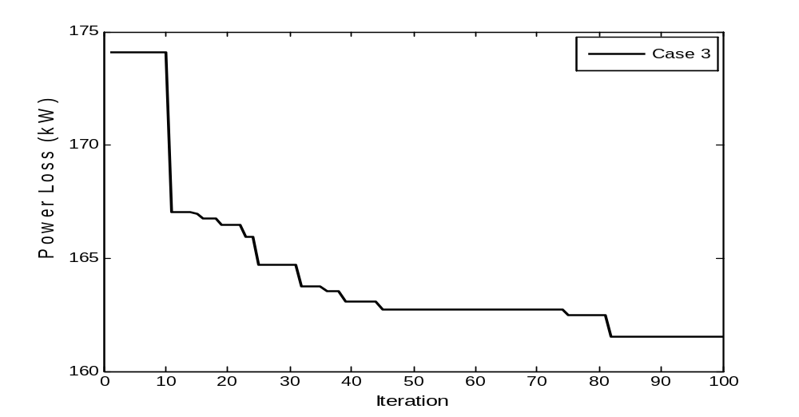
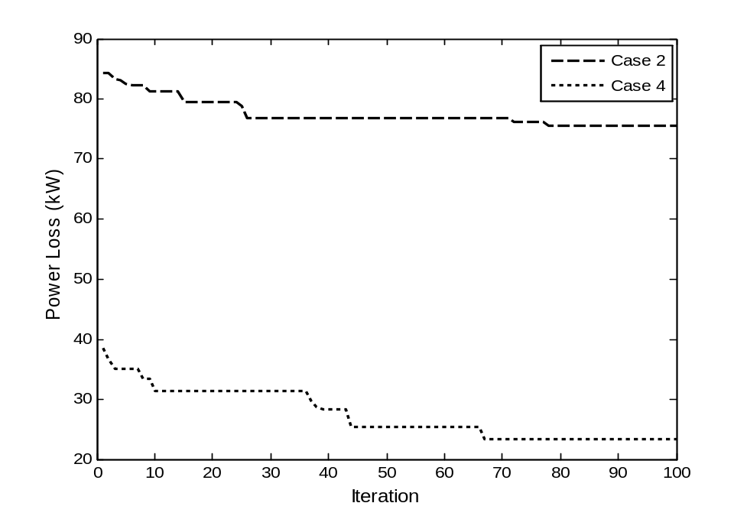
Fig. 6.1 Convergence curves of the BBA for minimizing the total power loss for 34-bus test system
Fig. 6.2 shows the voltage profiles for cases 1-4, when the total power loss minimization is considered as an objective function. The voltage profiles are improved at cases 2-4, where the voltage profile improvement based on case 4 is better than that obtained from other cases, while the average values of voltages are 0.9657, 0.9861, 0.9702 and 0.9910 for cases 1-4, respectively. Moreover, the minimum voltage limit is violated at buses starts from 22 to 27 in case 1.
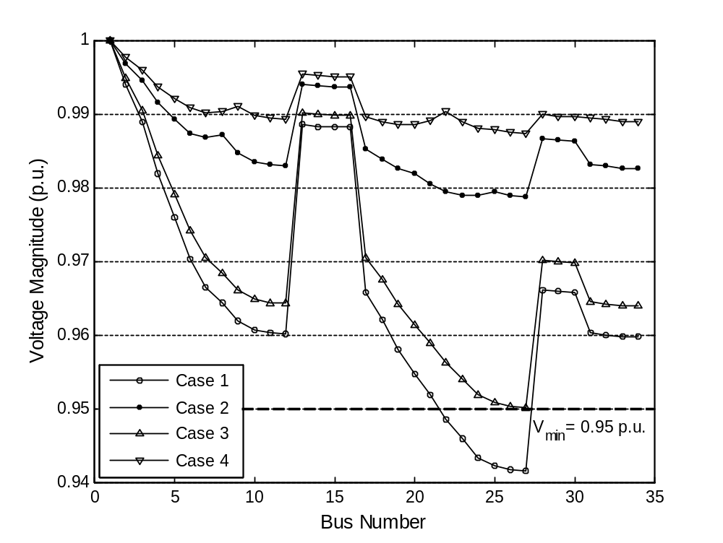
Fig. 6.2 Voltage profile at different cases for 34-bus test system
6.4.2.2 EDN radial distribution system
Tables 6.6-6.8 show the optimal locations and sizes of DGs and the capacitors required to reduce the total active power loss as an objective function for cases 2-4 for the EDN system.
Table 6.6 presents the optimal solution for case 2 using the proposed procedure, when only active power from DGs is injected. It can be observed that, the initial power loss without DGs is reduced from 805.73 kW to 544.03 kW after placement of DGs. The optimal locations of DGs are at buses {19,23,25} with total rating power 3912.9 kW. Moreover, the minimum and maximum voltage magnitudes are improved.

Table 6.6 Optimal locations and sizes of DGs at unity power factor using the proposed method for EDN system (case 2)
Items | Un-compensated  (Case 1) | Compensated (Case 2)
Optimal locations and sizes of DGs (kW) | - | 19 | 870.4
Optimal locations and sizes of DGs (kW) | - | 23 | 1912.2
Optimal locations and sizes of DGs (kW) | - | 25 | 1130.3
Total size | - | 3912.9
Total losses (kW) | 805.73 | 544.03
Minimum bus voltage(p.u.) | 0.9463 (#30) | 0.9654 (#29)
Maximum bus voltage(p.u.) | 0.9854 (#2) | 0.9874 (#2)
Overall power factor | 0.8457 | 0.7945

Table 6.7 presents the optimal solution for case 3 using the proposed procedure, when only reactive power from capacitors is injected. It is clear that, the initial power loss without compensation is reduced from 805.73 kW to 652.87 kW after placement of capacitors. The optimal locations of capacitors are at buses {16,18,20,22} with total rating power 4614.6 kVAR. Moreover, the minimum and maximum voltage magnitudes and overall system power factor are improved.
Table 6.7 Optimal locations and sizes of capacitors using the proposed method for EDN system (case 3)
Items | Un-compensated  (Case 1) | Compensated (Case 3)
Optimal locations and sizes of capacitors (kVAR) | - | 16 | 1022.7
Optimal locations and sizes of capacitors (kVAR) | - | 18 | 1200
Optimal locations and sizes of capacitors (kVAR) | - | 20 | 1200
Optimal locations and sizes of capacitors (kVAR) | - | 22 | 1191.8
Total size | - | 4614.6
Total losses (kW) | 805.73 | 652.87
Minimum bus voltage(p.u.) | 0.9463 (#30) | 0.9519 (#30)
Maximum bus voltage(p.u.) | 0.9854 (#2) | 0.9867 (#2)
Overall power factor | 0.8457 | 0.9202

Table 6.8 presents the optimal solution for case 4 using the proposed procedure, when active and reactive power from DGs are injected. It can be observed that, the initial power loss without compensation is reduced from 805.73 kW to 464.66 kW after placement of DGs. The optimal locations of DGs are at buses {20,21,25} with total rating power 3893.3 kW and 1885.6 kVAR. Moreover, the minimum and maximum voltage magnitudes and overall system power factor are improved after placement of DGs.

Table 6.8 Optimal locations and sizes of DGs at 0.9 power factor using the proposed method for EDN system (case 4)
Items | Un-compensated  (Case 1) | Compensated (Case 4)
Optimal locations and sizes of DGs (kW) | - | Locations | DG size (kW) | DG size (kVAR)
Optimal locations and sizes of DGs (kW) | - | 20 | 1300.7 | 630
Optimal locations and sizes of DGs (kW) | - | 21 | 1206.5 | 584.3
Optimal locations and sizes of DGs (kW) | - | 25 | 1386 | 671.3
Total size | - | - | 3893.3 | 1885.6
Total losses (kW) | 805.73 | 464.66
Minimum bus voltage(p.u.) | 0.9463 (#30) | 0.9679 (#29)
Maximum bus voltage(p.u.) | 0.9854 (#2) | 0.9879 (#2)
Overall power factor | 0.8457 | 0.8336

From these Tables, the total power loss is reduced using the proposed method. Case 4 gives the better results for the considering the objective function and constraints than that other cases. Moreover, the overall power factor is improved after placement of DGs and capacitors. In addition, the overall power factor are within permissible limits.
Fig. 6.3 shows the convergence curves of the BBA to reduce the total power loss using the DGs and capacitors for EDN system. It is clear that, the BBA is able to reach the optimal solution with more accuracy and efficiency.
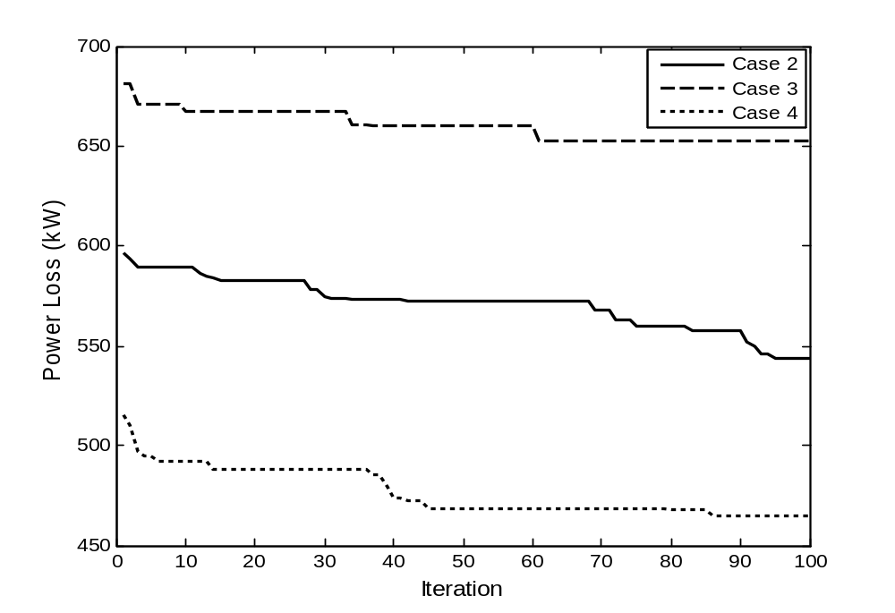
Fig. 6.3 Convergence curves of the BBA for minimizing the total power loss for EDN system
Fig. 6.4 shows the voltage profiles for cases 1-4, when the total power loss minimization is considered as an objective function. The voltage profiles are improved at cases 2-4, where the voltage profile improvement based on case 4 is better than that obtained from other cases, while the average values of voltages are 0.9644, 0.9731, 0.9678 and 0.9745 for cases 1-4, respectively. Moreover, the minimum voltage limit is violated at buses starts from 24 to 30 in case 1.
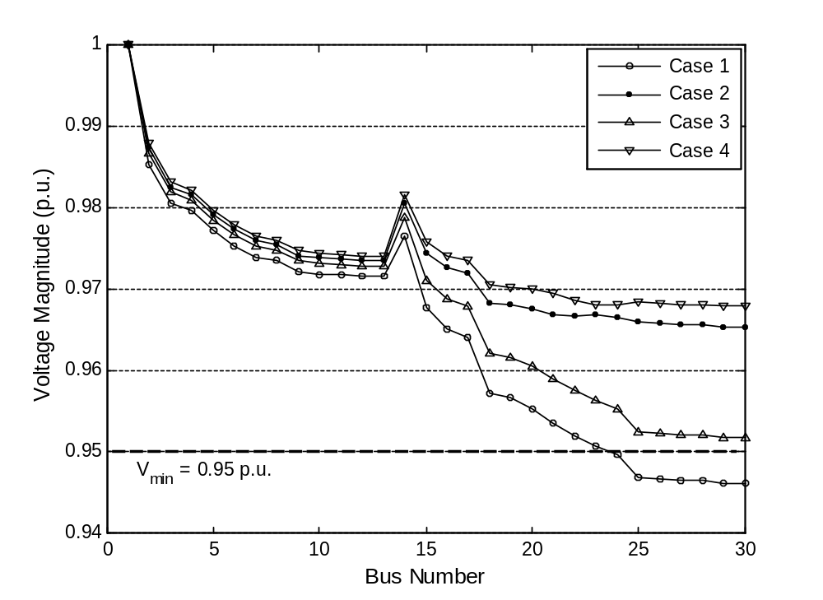
Fig. 6.4 Voltage profile at different for END system

